**AI Automation Project**

MGT 5804

*Abhay Pai*

**Section One: Overview of the Strategic Problem**

**Company:**

*Cleverest.ai*, an AI-powered Personalized Learning SaaS platform that integrates with learning management systems (LMS) like Canvas and Moodle to provide a data-driven personalized learning experience for learners at all stages of life.

**Key Strategic Problems:**

*Problem 1:* Inaccurate personalization and adaptive Learning.

*Problem 2:* Sparse learning content library with irrelevant material.

*Problem 3:* Issues with mainstream market adoption and ‘crossing the chasm’.

*Problem 4:* Unreliable platform and issues with scalability and data privacy.

**AI-Powered Solutions:**

*Solution 1:* **ML algorithm to analyze student data and identify type of student**. Netflix-like user grouping helps to create learning paths, student assessments and adaptive content recommendations.

*Solution 2:* **GPT models to web-scrape files and add to the library**. Also, use GPT models to create personalized learning materials according to the level of the student.

*Solution 3:* **AI model to analyze user behavior data** and enhance UI and UX paired with customer feedback, which can augment the customer experience and increase adoption.

*Solution 4:***Implement AI-based models for dynamic resource allocation for load balancing** on the cloud. **Analyze time zone-based user patterns** for predictive resource allocation to servers. **Use AI-based anonymization techniques** that makes it impossible to match data with its users, in addition to platform encryption.

**Section Two: Customer Segmentation Strategy**

**Target Segment in the Technology Adoption Life Cycle:**

Our company targets its products to the **“Early adopter”** customers as the main adopter segment. Our company’s target customer segment consists of **Instructors and Educational Institutions**. Early Adopters are typically tech-savvy and are willing to take risks on new technologies and appreciate the potential benefits they can provide. Cleverest.ai will face some scepticism from Late Majority adopters, but Early adopters will help to establish credibility and provide feedback.

**Objectives of target customers while evaluating tools they use to complete their core jobs:**

|  |  |  |
| --- | --- | --- |
| **Functional Objectives** | **Emotional Objectives** | **Social Objectives** |
| Streamline administrative tasks and reduce manual effort for themselves | Experience a sense of control over the learning process | Contribute to enhancing educational practices and methodologies |
| Enhance student engagement and learning outcomes | Reduce stress and anxiety of managing students of different levels | Aligns with their learner-centric ideology to provide high quality education |

**Section Three: Outline AI/Data Strategy**

**Data Pipeline**

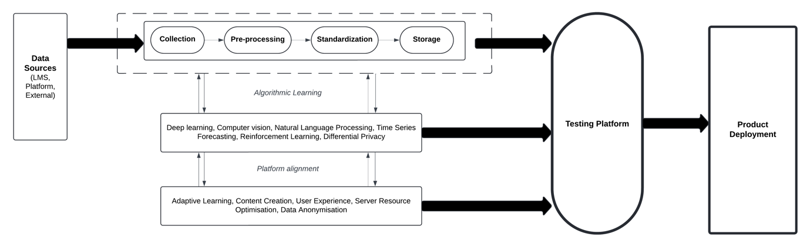

**Data collected**

1. *LMS Data* 
   1. Student profiles
   2. Courses enrolled in
   3. Instructors for each course
   4. Assignments and Grades
2. *Platform Data* 
   1. User activity
   2. Content consumed
   3. Feedback
   4. User performance data
3. *External Resources* 
   1. Open-source educational material
   2. Multimedia content

**Key AI algorithms:**

1. *Deep Learning Algorithm* 
   1. Analysing student data and categorizing them into similar clusters, leveraging on Netflix’s Collaborative Filtering method. (Problem 1)
2. *Computer Vision Algorithm* 
   1. Analysing visual content and curating video content. (Problem 2)
3. *Natural Language Processing Algorithm* (especially GPT models)
   1. Web scraping and text summarization to generate adaptive personalised material. (Problem 2)
   2. Sentiment analysis on user reviews and customer feedback to enhance UX and increase market adoption. (Problem 3)
4. *Time Series Forecasting Algorithm* 
   1. Analyse user behaviour patterns to predict server usage and resource allocation. (Problem 4)
5. *Reinforcement Learning Algorithm* 
   1. Creating adaptive learning path and optimizing content for student levels. (Problem 1)
   2. For optimising resource allocation and workload distribution across the cloud servers. (Problem 4)
6. *Differential Privacy* 
   1. Addition of noise to data, ensuring data anonymisation and makes it hard for outsiders to identify the user behind the data. (Problem 4)

**Section Four: Overview of Value Network & Ecosystem Strategy**

**Key players of the value network:**

1. **Supporting Infrastructure:** Cloud providers and data servers that power the platform, enabling scalability, performance, and reliability of personalized learning experiences.
2. **Educational Institutions:** Provide access to student data, course materials, and serve as the primary customers.
3. **Instructors:** Providing subject matter expertise and feedback that help refine the platform's personalized learning.
4. **LMS Providers:** Allow seamless access to student data and facilitate delivery of personalized learning within existing ecosystems.
5. **Open-Source Educational Providers:** Third-party content providers and subject matter experts that contribute learning materials and knowledge to enrich content library.
6. **Students:** End-users of the app, provide essential data on which the platform is dependent for accuracy and personalisation.
7. **Platform Experts:** AI and ML experts who develop and optimize the underlying algorithms infrastructure that power personalized learning capabilities.

**Technology strategy:**

1. **Seamless Integration** with Learning Management Systems for smooth data transfer.
2. **Advanced AI/ML Algorithms** that create value and build competitive advantage.
3. **Dedicated R&D team** to improve value proposition and sustain competitive advantage.
4. Cleverest’s outbound marketing team will try to **target the niche of online schools and virtual learning platforms** because the platform best addresses their pain points, allowing them to reap the most benefits. This will help Cleverest to gain a foothold in the market and boost their bid to go mainstream.
5. **Raise funds to facilitate early investments** in technology development of the platform to pre-empt rivals that try to imitate the innovation.
6. **Tier-based Freemium Subscription Model:**

Free version provides barebones features, that helps in faster customer acquisition and lower barrier to entry for customers, and later exploiting switching costs as they upsell tiers since institutions are now intertwined in Cleverest’s ecosystem.

**Sources of Competitive Advantage:**

1. Advanced AI/ML Algorithms allow the company to provide an in-depth, accurate, and personalized learning experience to its users as compared to competitors.
2. By targeting early adopters in educational institutions and instructors familiar with LMS platforms (especially in the tech-savvy online teaching segment), Cleverest.ai can gather valuable feedback and refine their platform quickly, potentially outpacing competitors focused on a broader audience.
3. Leveraging student data for in-depth personalization and adaptive learning paths positions Cleverest.ai to offer a more tailored experience than competitors.
4. The freemium subscription model can attract new users with a lower barrier to entry, leading to ‘crossing the chasm’, higher switching costs, and stronger network effects compared to competitors with paid models.

**Problems solved by the strategy:**

1. **Inaccurate personalization and Adaptive Learning:** Advanced AI algorithms are used to analyse student data for better user clustering and adaptive learning paths.
2. **Sparse Learning content library with irrelevant curation:** NLP algorithms can scrape content and generate personalized materials, while computer vision algorithms can curate video content, enriching the library and addressing relevance.
3. **Issues with mainstream market adoption and ‘crossing the chasm’:** Focusing on early adopters and LMS integration creates a dedicated user base and leverages existing educational ecosystems, easing mainstream adoption later.
4. **Unreliable platform and issues with scalability and data privacy:**  Forecasting helps with resource allocation and server optimization for scalability. Differential privacy techniques can anonymize data.